The states are divided into four main states as shown in the figure.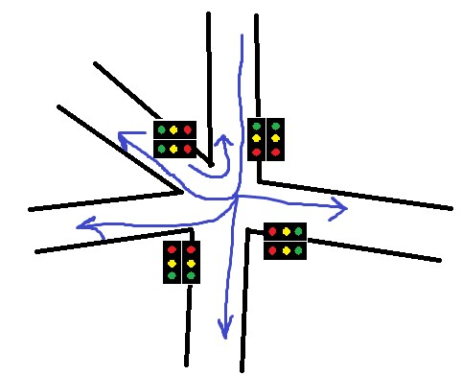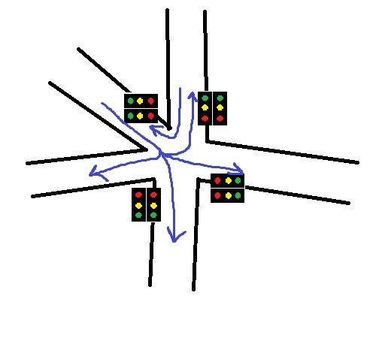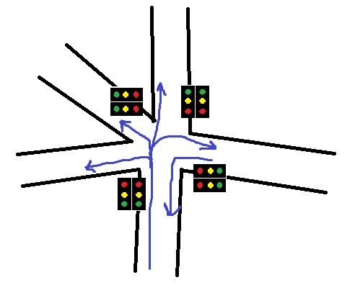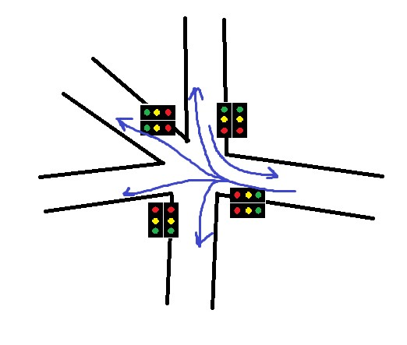

Transition between states is properly done with no intersecting pathways having green at the same time. With these transition states there are 16 states in total.

Pedestrian crossing is not considered as the Borella Junction has an underground crossing.

A 10 bit counter is used, and throughout each full count the transition between states happen sequentially, and then the procedure will iterate.